**Ex 9 Fundamental operations of Perl**

**Date: 10.11.2020**

**Aim:**

To study and implement the fundamental operations of Perl programming.

**Description**

Perl is a programming language developed by Larry Wall, specially designed for text processing. It stands for Practical Extraction and Report Language. It runs on a variety of platforms, such as Windows, Mac OS, and the various versions of UNIX. This tutorial provides a complete understanding of Perl.

**Perl Arrays**

An array is a variable that stores an ordered list of scalar values. Array variables are preceded by an "at" (@) sign. To refer to a single element of an array, you will use the dollar sign ($) with the variable name followed by the index of the element in square brackets.

**Here is a simple example of using the array variables :**

#!/usr/bin/perl

@ages = (25, 30, 40);

@names = ("John Paul", "Lisa", "Kumar");

print "\$ages[0] = $ages[0]\n";

print "\$ages[1] = $ages[1]\n";

print "\$ages[2] = $ages[2]\n";

print "\$names[0] = $names[0]\n";

print "\$names[1] = $names[1]\n";

print "\$names[2] = $names[2]\n";

**Arithmetic Operators of Perl**

|  |  |
| --- | --- |
| **Sl.No** | **Operator & Description** |
| **1** | + ( Addition )  Example − $a + $b will give 30 |
| **2** | - (Subtraction)  Example − $a - $b will give -10 |
| **3** | * (Multiplication)  Example − $a * $b will give 200 |
| **4** | / (Division)  Example − $b / $a will give 2 |
| **5** | % (Modulus)  Example − $b % $a will give 0 |
| **6** | ** (Exponent)  Example − $a**$b will give 10 to the power 20 |

**Exercise**

**1. Demonstrate various operators in Perl.**

**Source Code :**

print("choose an option: \n 1.Arithmetic operation \n

2. comparison operation \n 3.string operation \n 4.Bitwise operation\n");

$c = <STDIN>;

if ($c == 1)

{

print("ARITHMETIC OPERATIONS\n");

print("Enter two values\n");

$a = <STDIN>;

$b = <STDIN>;

print("choose an option: \n 1.Addition \n 2.Subraction \n 3.Multiplication \n 4.Division \n 5.Modulus \n");

$op = <STDIN>;

if($OP == 1)

{

$tot = $a+$b;

print("sum of numbers: $tot\n");

}

elsif ($op == 2)

{

$tot = $a-$b;

print("Difference beteween both values: $tot\n");

}

elsif($op == 3)

{

$tot = $a*$b;

print("product of both the numbers: $tot\n")

}

elsif ($op == 4)

{

$tot = $a/$b;

print("Quotinent of both the numbers: $tot\n");

}

elsif ($op == 5)

{

$tot = $a%$b;

print("Modulus of both the numbers: $tot\n");

}

else

{

print ("Invalid Option\n");

}

}

elsif ($c == 2)

{

print("COMPARISION OPERATOR\n");

print("Enter two values\n");

$a = <STDIN>;

$b = <STDIN>;

if($a == $b)

{

print("The values are equal\n");

}

elsif($a > $b)

{

print ("Greater value: $a\n");

print ("Lower values: $b\n");

}

else

{

print("Lower value: $a\n");

print("Greater value: $b\n");

}

if($a != $b)

{

print("Both are not equal\n");

}

}

elsif ($c == 3)

{

print("STRING OPERATION\n");

print("Enter two strings\n");

$x = <STDIN>;

$y = <STDIN>;

$z = $x.$y;

print("Concatenated String: $z");

}

elsif ($c == 4)

{

print("BITWISE OPERATOR\n");

print("Enter two values\n");

$a = <STDIN>;

$b = <STDIN>;

$and = $a & $b;

print("Performing bitwise AND: $and\n");

$or = $a | $b;

print("Printing bitwise OR: $or");

$left = $a<<2;

print("Performing left shift: $left");

$right = $a>>2;

print("Performing right shift: $right");

}

else

{

print("Invalid Operation");

}

**Output :**

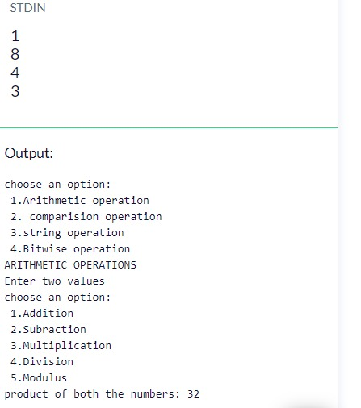

**2.Print 10 inputs received from the user.**

**Source Code :**

print("Enter 10 values\n");

for($i=0;$i<10;$i++)

{

$arr[$i]=<STDIN>;

}

print("The Values\n");

for($i=0;$i<10;$i++)

{

print("$arr[$i]");

}

**Output :**

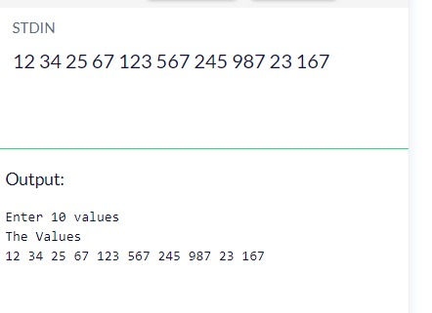

**Results:**

The study and implementation of fundamental operations of Perl programming are studied and executed.

**Video :**

https://youtu.be/XuMDg-PVZzE